EXP NO 6: CREATE A SIMPLE CLOUD SOFTWARE APPLICATION FOR PRODUCT SELLING USING ANY CLOUD SERVICE PROVIDER TO DEMONSTRAT SAAS.
DATE:
AIM:
To create a simple cloud software application for product selling using any cloud
service provider to demonstrate saas.
PROCEDURE:
step1: Go to zoho.com.
step 2: Log into the zoho.com.
step 3: Select one application step.
step4: Enter application name as product selling.
step 5: Created new application as product selling.
step 6: Select one form
step 7: The software has been created.

IMPLEMENTATION
STEP1: GO TO ZOHO.COM.
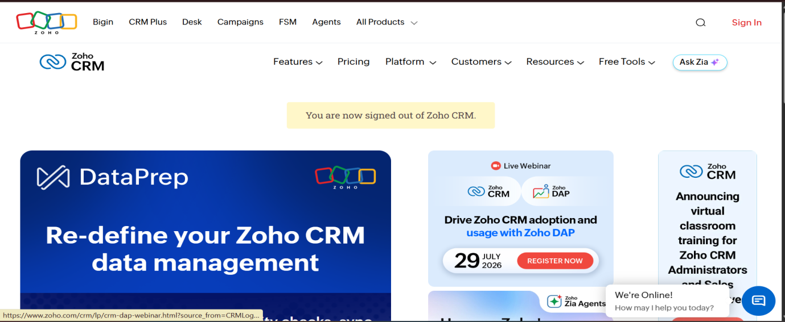
STEP 2: LOG INTO THE ZOHO.COM.
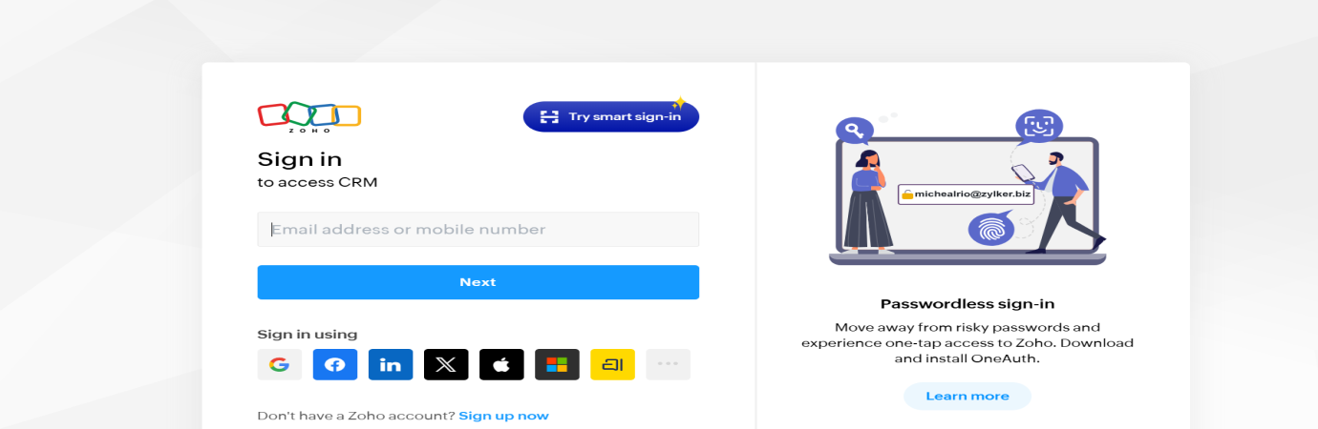
STEP 3: SELECT ONE APPLICATION STEP.
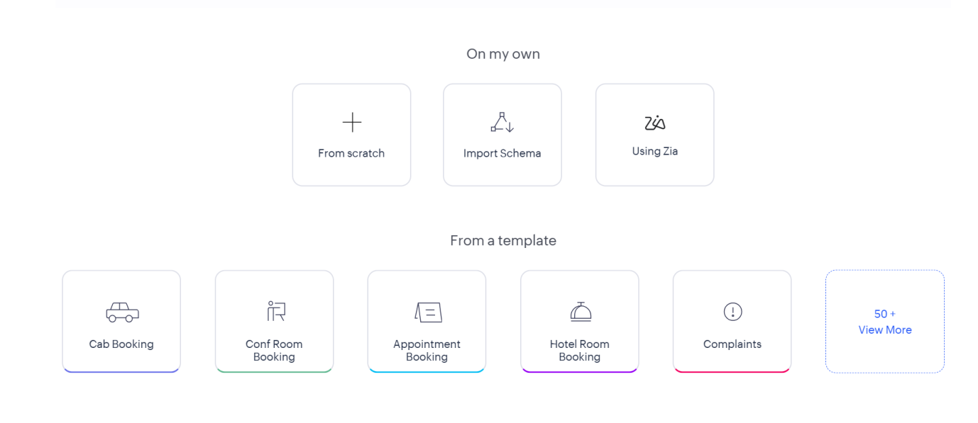
STEP4: ENTER APPLICATION NAME AS PRODUCT SELLING.
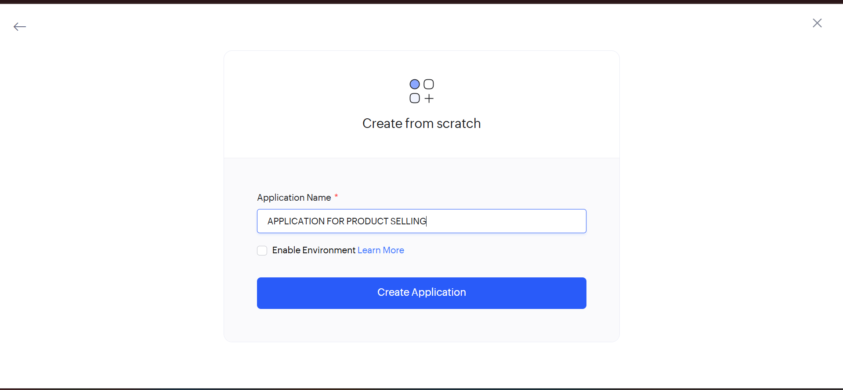

STEP 5: CREATED NEW APPLICATION AS PRODUCT SELLING.


STEP 6: SELECT ONE FORM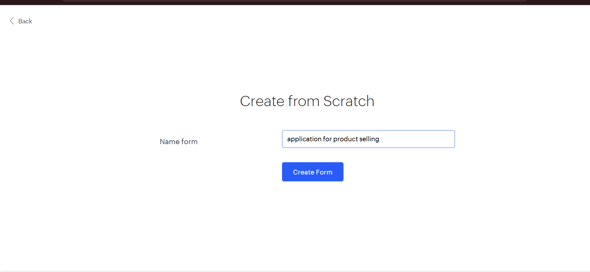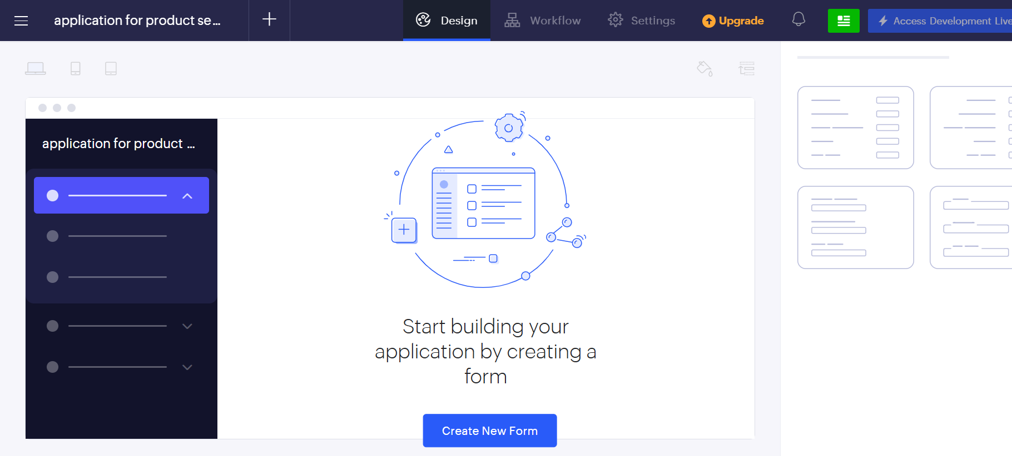

STEP 7: THE SOFTWARE HAS BEEN CREATED.
